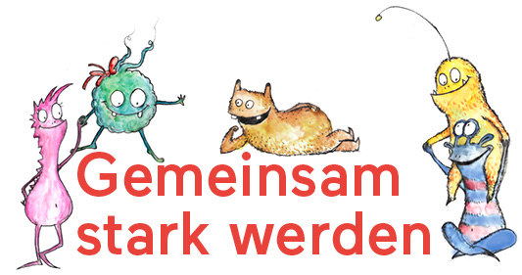
Dear Parents!

This year we have started implementing a new program in class. Since your child will be participating in this program, we would like to introduce you to the content of “Gemeinsam stark werden“ (“Growing strong together“)
“Gemeinsam stark werden“ is a school program aiming at personality formation and the promotion of health. It is based on the WHO (World Health Organization) recommendations and imparts life skills.
With quality assured classroom materials the children learn how to cope with stress and strong feelings. Playfully, they learn how to solve problems and manage group conflicts. Self-esteem, the ability to communicate and empathy are further key issues.
In specific classroom units, “Gemeinsam stark werden“ creates learning situations in which the children develop firm social skills so that primary school becomes a springboard to a successful life.
In various studies, promoting life skills has proven an effective method for the prevention of problematic behavior, such as aggression and violence, addiction and depression. It increases the children's self-confidence which makes them less vulnerable to peer pressure or negative influences of media.
“Gemeinsam stark werden“ has been developed especially for primary school. All teachers conducting this program have been professionally trained. In class, issues like “Together we are strong”, “Let's talk about it”, “My dreams and goals”, “What do I really need?”, “We gather new strength”, “I get to know my feelings” and many more are dealt with.
The purpose of the program is to give the children a strong self-confidence already at primary school age so they will be able to cope with life's challenges throughout their school career. It has been developped in close cooperation with teachers from primary schools as well as with prevention experts, considering the latest findings from psychology and pedagogy.
We are happy to be able to offer our students “Gemeinsam stark werden”.

MUSTERSCHULE XY,
Durchführende Lehrperson

